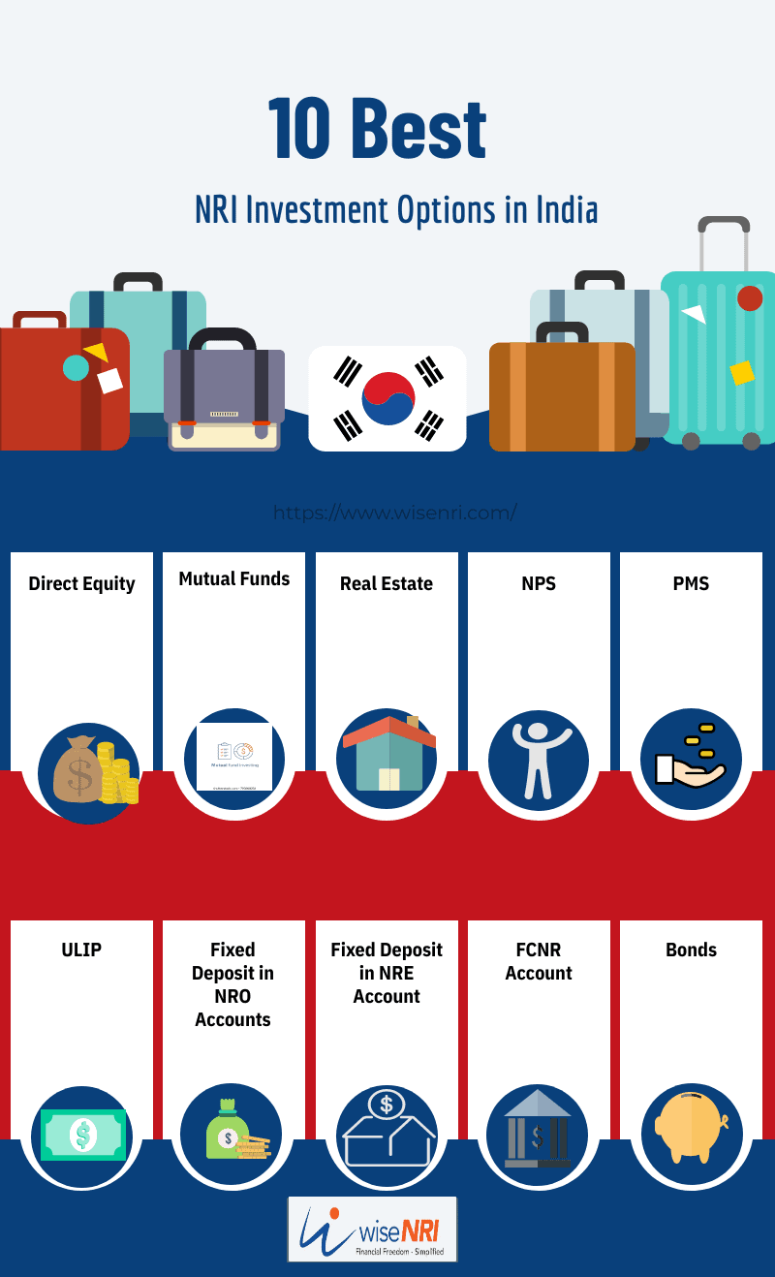

Table of Contents
- ‍Who is a Non-Resident Indian (NRI)?
An NRI is a citizen of India who currently does not reside within India.For tax purposes, however, you are considered an NRI if you have spent more than 182 days residing outside of India within a financial year. India’s financial year goes from the 1st of April to the 31st of March.

- ‍NRI investment options
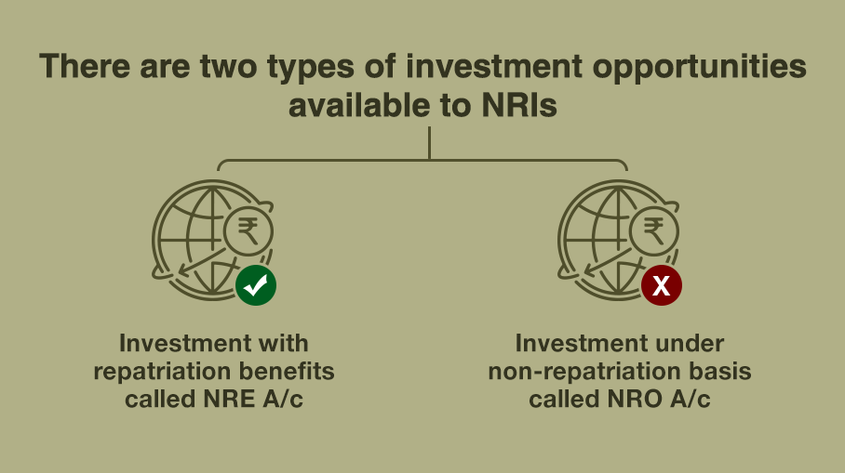
- Fixed Deposits or FDs
- Non-Resident External (NRE) Fixed Deposit
You can open an NRE FD account to deposit your earnings in foreign currency converted to Indian rupees. The principal and the interest can be fully repatriated later to your country of residence if you wish.
- Foreign Currency Non-Resident (Bank) [FCNR(B)] Fixed Deposit
An FCNR (B) fixed deposit account allows you to deposit funds in a foreign currency in India. An FCNR account can help you to tide over currency exchange rate fluctuations. FCNR FD interest rates vary based on the currency that it is held in. The interest earned is not taxable in India, and both the principal amount and the interest can be completely repatriated to your country of residence later if you choose to do so.

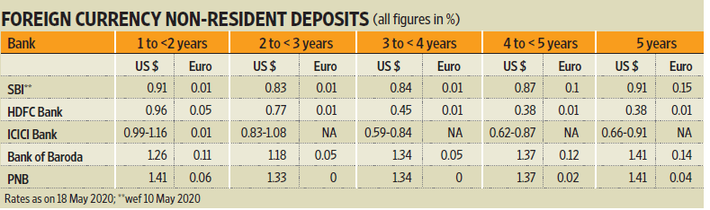
- Non-Resident Ordinary (NRO) Fixed Deposit
You may open an NRO Fixed Deposit account to maintain and save your income generated in India in Indian Rupees. This income may be from dividends, rental income, pension and similar sources. However, Interest earned is taxable in India at 30% along with surcharge and cess
- National Pension Scheme or NPS
The NPS is floated by the government of India and allows NRIs to invest in equity funds, debt funds or a combination of both.
NPS is available to individuals between the age of 18 years and 60 years.(extendable upto 70 years) You will need documents like a PAN card and an Aadhaar card, a Non-Resident External (NRE) account or a Non-Resident Ordinary (NRO) account
- Equity
Non-Resident Indians may directly invest in the Indian stock market under the Portfolio Investment Scheme (PIS) of the RBI.
NRIs need to have the following accounts for equity investments:
- Non-Resident External (NRE) Account
- Non-Resident Ordinary (NRO) Account
- NRI Demat Account
- NRI Trading Account with a registered broker
Please note that Income from dividends and capital gains earned by NRIs from stocks and equity-oriented mutual funds schemes are taxed in India.
- Mutual Funds
Yes, like resident Indians, NRIs too can invest in mutual funds in India. However, only a few Mutual fund houses offer mutual funds to NRIs based in the USA and Canada. NRIs residing in the USA and Canada must comply with the Fair and Accurate Credit Transactions Act (FACTA) requirements to invest in mutual funds in India.
Do you have financial goals? Do you want to invest in mutual funds? Mutual fund investments are simple and secure with the Fi money mobile app. Get your mandate, set your Systematic Investment Plan (SIP) date and amount, and get going.
- Real Estate
Real estate is considered a stable investment with handsome returns over the long term. NRIs may purchase residential and commercial real estate properties in India. However, you cannot buy agricultural land.
NRIs may use the following bank accounts for property transactions in India:
- Non-Resident External Account
- Non-Resident Ordinary Account
- Foreign Currency Non-Resident Account
- Public Provident Fund or PPF
You can continue with your PPF account, which you opened as a resident Indian. However, if you don't have a PPF account, you can’t apply for it as an NRI. Also, note that you cannot extend your PPF account after the maturity period of 15 years.
Interest earned and maturity is Tax exempt
10.Bonds and Non-Convertible Debentures (NCDs)
As an NRI, you may invest in bonds and NCDs in India. You can also invest in government securities in the form of NRI bonds without any ceiling limit in certain categories.
Here are the three main categories of bonds you can invest in:
- Public Sector Unit or PSU Bonds
As a holder of PSU bonds, you lend money to a PSU company, and it promises to pay interest on the maturity date. The interest rate on the PSU bond is a factor of the creditworthiness of the issuing PSU company.
The interest earned on PSU bonds is tax-free U/S 10 (15) (IV) (h). If you sell them after owning them for over three years, the investment is taxed at 20 per cent. NRIs can also claim tax deductions if they invest in capital gain bonds by REC and NHAI under section 54 EC.
- Non-Convertible Debentures (NCD)
You can invest in non-convertible debentures (NCDs), considered a secure and long-term investment. They are secured by the company’s assets.
- Perpetual Bonds
Perpetual bonds do not have a fixed maturity date. The issuing company promises to pay the investor a set amount of returns per year.
11. Pre-IPO investment
You can buy and sell shares of a company that is yet to be listed on a public exchange in the pre-IPO market. Private companies sell their shares through an investment firm that facilitates the transaction. The units will be deposited in your NRI Demat account when you buy unlisted shares.
Pre-IPO shares may have a massive upside if the company does well. However, these investments are riskier than listed shares because this market is less regulated than the regular equity market.

12. ULIP

UNIT LINKED INSURANCE SCHEMES
ULIPs or other insurance products are sold to NRIs by bankers to maximize their earnings in the short term as these products have heavy upfront commissions.

Frequently Asked Questions

1) Who regulates NRI Investments in India?
NRI investment in India is regulated by the Reserve Bank of India (RBI) under the Foreign Exchange Management Act (FEMA) and the Securities and Exchange Board of India (SEBI).

2) Can NRIs invest in India with just a PAN Card?
NRIs can invest in a mutual fund with a PAN card and NRE/NRO account. However, the documents required differ as per the asset class.

3) In which funds can NRIs invest?
NRIs can invest across mutual funds in India. However, for NRIs residing in the USA and Canada, it is mandatory to comply with the Fair and Accurate Credit Transactions Act requirements to invest in mutual funds in India.
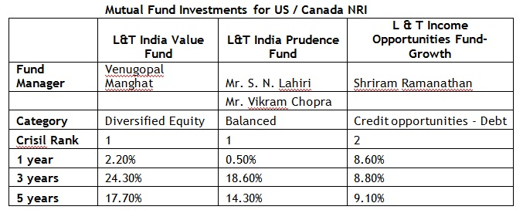
NRIs can invest in the Indian stock market directly under the Portfolio Investment Scheme (PINS) of RBI. NRIs are mandated to have an NRE/NRO bank account, a Demat account, and a trading account to invest in the Indian stock market

NO RISK SENIOR CITIZEN INVESTMENT
5 Best Investment Options to Invest 50 Lakhs for Monthly Income?
- Fixed Deposits (FD)
- Post Office Monthly Income Scheme (POMIS)
- Senior-Citizen Savings Scheme (SCSS)
- Corporate Deposits.
- Government Bond.

THESE ARE ILLUSTARTIVE AND BRIEF OPTIONS AND BASIC GUIDELINES.
INVESTMENT IS INDIVIDUAL SPECIFIC BASED ON NEED, LIQUIDITY, RETURN,SAFETY, RISK,GROWTH & TERM.
INVESTMENTS ARE PRONE TO MARKET,CURRENCY,POLITICAL,TECHNOLOGY RISKS

